Food Trucks are coming…to Libertytown,MD

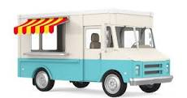
Starting April 8th,2024
2nd and 4th Monday of the month from 5:00 – 8:00 pm

Libertytown Fire Hall Grounds
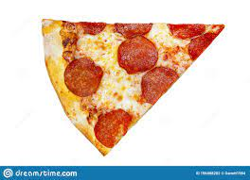

12027 South St. Libertytown, MD
Great food….. Plenty of parking,
picnic table seating, drinks.to-go options available.
Food Trucks are subject to change.
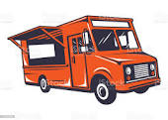
Different Trucks every other Monday including BBQ, Pizza, Mexican, Grilled Cheese, Desserts and more….Drinks for sale by the Libertytown Vol. Fire Dept. Aux.
For more info call 301-401-2824

Benefit: Libertytown Vol. Fire Dept. Aux

